Final Approach Hunting Pack

Features & Benefits
- 457593 REALTREE® MAX-5™
- 457594 MOSSY OAK® BLADES™
- Main Compartment 18”H x 13”W x 5”D
- Secondary Compartment 18”H x 13”W x 3”D
- Front accessory compartment
- Padded Waist belt
- Vented Back and shoulder straps
- Zip out gun sling
- Sternum strap
- Waterproof cell phone pocket
- Rugged 900D material
- Waterproof bottom
- Tree hook for flooded timber

Part No. Description UPC MSRP
457593 & 457594 Final Approach Hunting Pack 0-29757-57593-7 $88.45
0-29757-45759-2

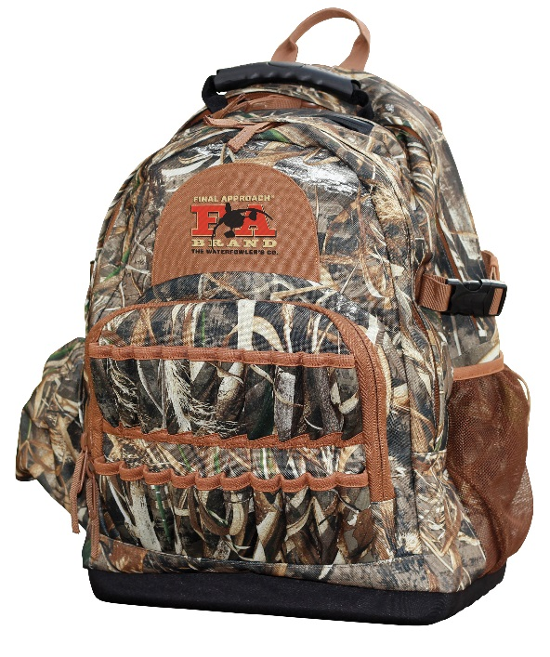
Final Approach Timber Shoulder Bag

Features & Benefits
- 458493 REALTREE® MAX-5™
- 458494 MOSSY OAK® BLADES™
- Main compartment 11”H x 13”W x 5”D
- Multiple accessory pockets
- Rugged 900D material
- Tree hook for flooded timber
- Across the body strap for hunting on the go
- Waterproof lid
- 12 shotgun shell loops

Part No. Description UPC MSRP
458493 & 458494 Final Approach Timber Shoulder Bag 0-29757-58493-9 $49.45
0-29757-58494-6

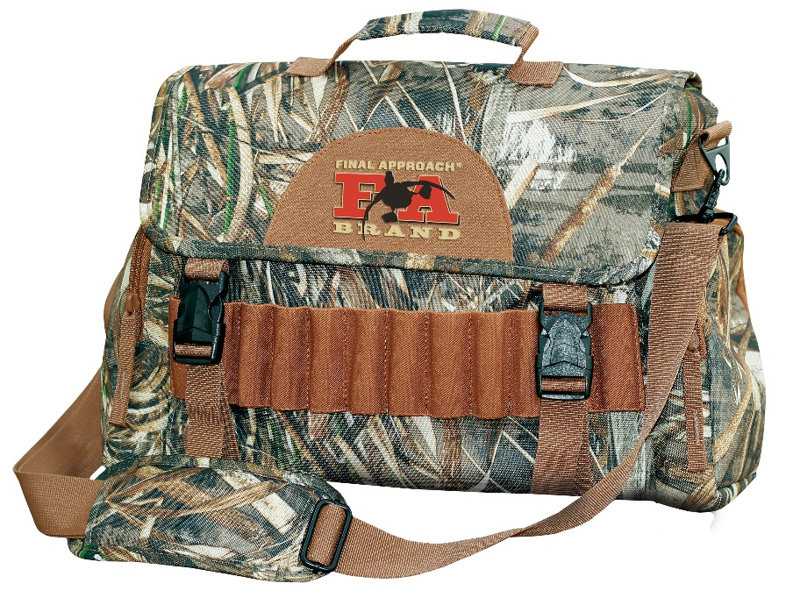
Final Approach Floating Medium Blind Bag

Features & Benefits
- 458491 REALTREE® MAX-5™
- 458492 MOSSY OAK® BLADES™
- Main compartment 10”H x 13.5”W x 9.5”D
- 2 side accessory pockets
- Double zippered top with a storm flap
- Rugged 900D material
- Waterproof bottom
- Removable interior divider
- Waterproof cell phone pocket

Part No. Description UPC MSRP
457593 & 457594 Final Approach Floating Medium Blind Bag 0-29757-58491-5 $88.45
0-29757-45849-0

